Adding thread group plugin to Jmeter:

* Go to any browser and type JMeter plugins manager.
* Click on the link https://jmeter-plugins.org.
* Now, once you click on **Install**, you will get a jar file that will install the plugins.
* The easiest way to get the plugins is to install [the **Plugins Manager**](https://jmeter-plugins.org/wiki/PluginsManager/)[.](https://jmeter-plugins.org/install/)
* Now, [we'll be able to install any other plugin just by clicking a checkbox. Link:-Download](https://jmeter-plugins.org/install/)[plugins-manager.jar](https://jmeter-plugins.org/get/)[and put it into lib/ext directory, then restart JMeter.](https://jmeter-plugins.org/install/)
* The downloaded plugins_manager.jar file will look like: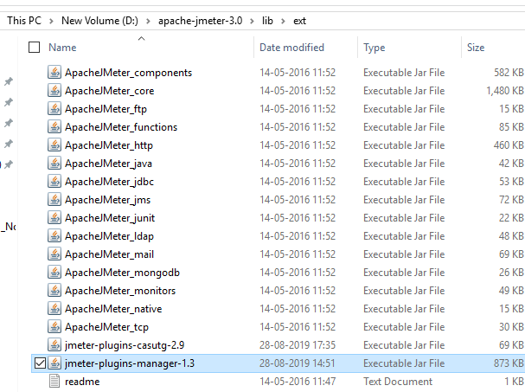

Now open the jmeter 🡪 go to options🡪 click on plugins manager 🡪 go to available plugins 🡪 search for custom plugins and install the plugins , click on Apply changes and restart the jmeter.

